**Web Technical Question**

1) What is Website and WWW?

* Website – Everyday you visit on internet
* Follows some rules & regulations i.e. **client-server architecture standard**
* Websites – providing information from anywhere in world
* WWW – world wide web called internet

2) What is client and server architecture ?

client : Request

Server : Response

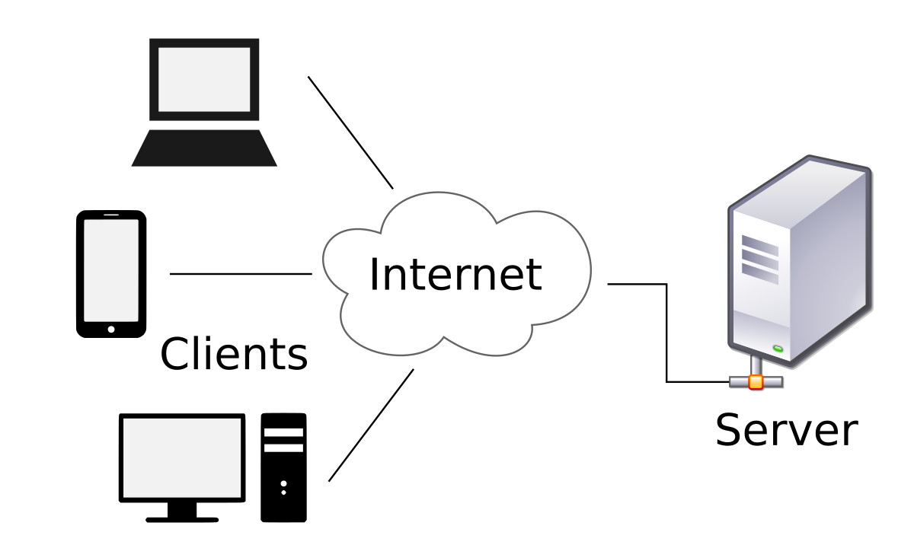

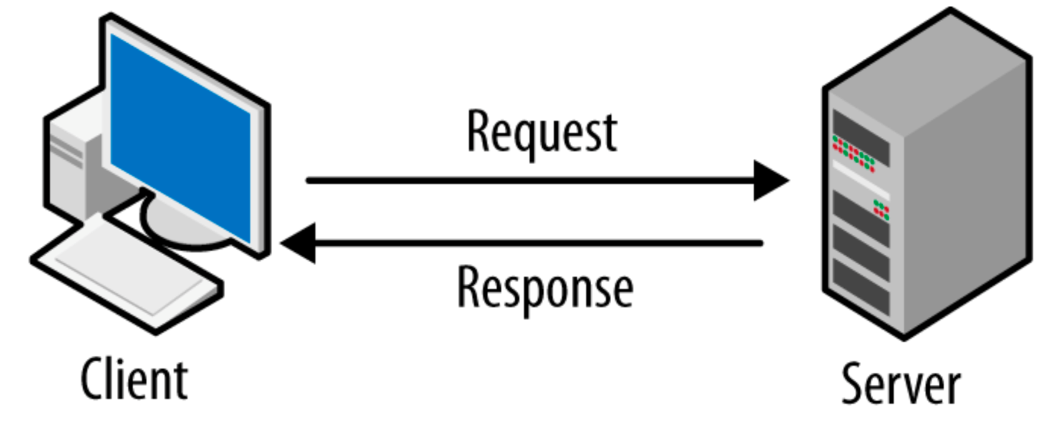

**Internet : http ( hyper text transfer protocol)**

3) What is web browser ?

google chrome / mozila firefox, opera, safari

**How to buy domain & server**

We can buy web hosting & domain **from goDaddy, hostinger**

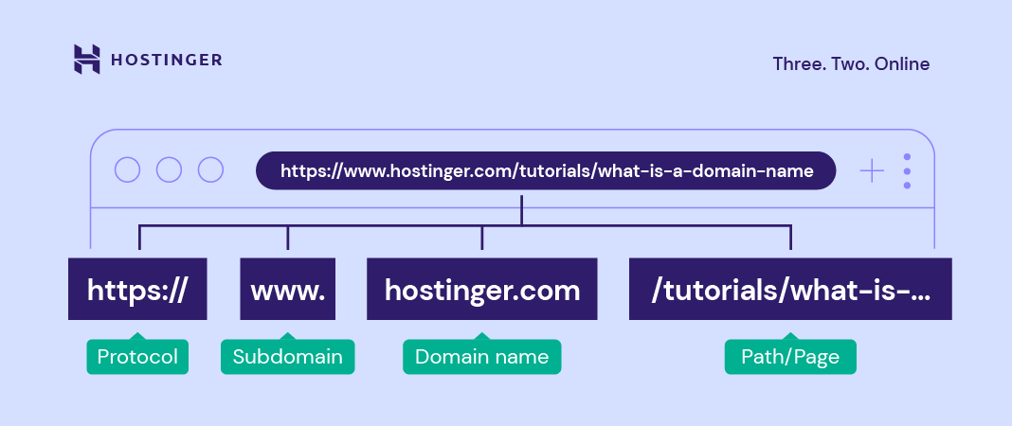

==================================================================================

4)What is web page ?

Web site contain the many pages that’s called Web Page Web page contain the information related to

5) What is home page ?

(First page of websites) When we open any kind of web site that show the first page and it contain all web pages links and it also show the primary contain in a page.

====================================================================================

Requirement

1. editors : notepad++ / sublime text / vs code

<https://notepad-plus-plus.org/downloads/v8.4/>

<https://www.sublimetext.com/3>

<https://code.visualstudio.com/download>

1. Browser : chrome / safari /mozilla

=================================================================================

8) What is html ?

* HTML (Hypertext Markup Language) is the language used to create web page documents.
* HTML stands for Hyper Text Markup Language
* An HTML file is a text file containing small markup **tags <> <h1> </h1>**  
  The markup tags tell the Web browser how to display the page  
  An HTML file must have an .htm or **.html** file extension  
  An HTML file can be created using a simple **text editor**

**<html>  
 <head>  
 <title>Title of Page</title>  
 </head>  
<body>  
 This is my first homepage.<b> This text is bold</b>  
</body>  
</html>**

* The first tag in your HTML document is <html>. This tag tells your browser that this is the start of an HTML document. The last tag in your document is </html>. This tag tells your browser that this is end of the HTML document.
* The text between the <head> tag and the </head> tag is header information. Header information is not displayed in the browser window. Title tag & favicon & external files
* The text between the <body> tags is the text that will be displayed in your browser.

9) **HTML Tags:**  
 HTML tags are used to mark-up HTML elements  
 HTML tags are surrounded by the two characters < and >  
 The surrounding characters are called angle brackets  
 HTML tags normally come in pairs like <b> and </b>  
 The first tag in a pair is the start tag, the second tag is the end tag  
 The text between the start and end tags is the element content  
 HTML **tags are not case sensitive,** <b> means the same as <B>

<head>/ <HEAD>

**Text Tag**